

**DESIGN AND IMPLEMENTATION OF A SALES ORDER PROCESSING AND INVOICE SYSTEM**

**BY**

**OBUVIE KELVIN AYODELE 19/2766**

**EJIKEME AKAOLISA EMMANUEL 18/0810**

**BINITIE SAMUEL 18/1904**

**A PROJECT SUBMITTED TO THE DEPARTMENT OF COMPUTER SCIENCE, SCHOOL OF COMPUTING AND ENGINEERING SCIENCES**

**IN PARTIAL FULFILMENT OF THE REQUIREMENTS FOR THE AWARD OF THE DEGREE OF BACHELOR OF SCIENCE,**

**BABCOCK UNIVERSITY, ILISHAN-REMO,**

**OGUN STATE,**

**NIGERIA.**

**SUPERVISOR:**

**PROF. SUNDAY IDOWU**

**2022**

**DECLARATION**

We declare that this project “Design and Implementation of a “Sales order processing and Invoicing system” was carried out by us:

_______________________ __________________

Obuvie Kelvin Ayodele Date

_______________________ __________________

Ejikeme Akaolisa Emmanuel Date

_______________________ __________________

Binitie Samuel Date

**CERTIFICATION**

We certify that this project was carried out by the following students under our supervision in the Department of Computer Science, Babcock University, Ilishan-Remo, Ogun State, Nigeria:

1. Obuvie Kelvin Ayodele
2. Ejikeme Akaolisa Emmanuel
3. Binitie Samuel

______________________________ ____________________

Prof. Sunday Idowu Date

(Supervisor)

______________________________ ____________________

External Examiner Date

______________________________ ____________________

Dr. Kuyoro Shade Date

(Head of Department)

**DEDICATION**

This Project is dedicated to the almighty God, who graced us with wisdom, Knowledge and understanding from the start of this Project until the very end. We also dedicate this project to our supervisor, parents and friends for their endless contributions, efforts and supports in ensuring our success in this work and most of all, making our stay in Babcock University a wonderful one.

**ACKNOWLEDGMENT**

First and foremost, my utmost Appreciation goes to the almighty God who gave me the strength, good health and protection through my educational pursuit. My special thanks go to my supervisor Prof. Idowu for his guidance all through the duration of this project work. I would love to specially thank my parents Mr. and Mrs. Obuvie for their love, care and support all through my stay at Babcock University. Finally, I wish to appreciate my siblings, for their beloved and kind gesture towards me. To all my friends in this prestigious university I say a huge thank you for all support and love all through my stay Babcock University I appreciate every one of you.

**OBUVIE KELVIN AYODELE**

First and Foremost, My Appreciation goes to God almighty for granting me the privilege to write this final year project in sound health and my parents for their spiritual and financial support during my stay in this prestigious university. I am also grateful to my supervisor Prof. Idowu for his supervision and advice which also contributed to the success of my final year project. Thank you and God bless you all. **EJIKEME AKAOLISA EMMANUEL**

First of all, I would like to thank God Almighty for giving me the opportunity and guidance to achieving my goal and to be successful in this part. Then I would like to thank my parents as well for being able to successfully complete this project with the help of their guidance and support. I am also grateful to my supervisor Prof. Idowu who gave me the golden opportunity to do this project. My thanks and appreciation also go to my colleagues in developing this project.

**BINITIE SAMUEL**

**ABSTRACT**

**S**ales order processing system is a critical component for any company's success, regardless of its industry. Because the order processing system is a part of the business system that generates reports for management level to forecast the trend of business, it is critical to have an appropriate response time and information about customers and products. This project is focused on the development and design a sales order processing and invoice system that provides a solution to the collection of information which is specially organized for rapid search and retrieval of information by using a database.

Using the Iterative model to define the stages used in the development of the system, it was the most suitable model because it is adaptable to changes to requirements throughout the development of the system. For the front-end of the system HTML was used for the structure, CSS for styling and JavaScript to make the system interactive while for the backend, MySQL was used for the database because it is secure and reliable. PHP was used to manage the server side and manage the database.

The system developed was able to handle data more efficiently and accurately compared to other systems. It was able to successfully store customers’ information in the database which was used to generate the invoice based on the sales order of the customer. The system was also capable of updating the database conveniently if there were changes to the system.

In conclusion, the sales order processing and invoice system project has been validated and verified. It meets up to the goals that were initially set at the onset of the project. The objectives of this study as initially stated in the previous chapters have been met. Sales order and invoice Management is a critical component of every business that must be handled with care.

Keywords: Sales order, invoice, system, information and management

Number of words: 303

**TABLE OF CONTENTS**

Title page - - - - - - - - - - - - - - - - - - - - - - - - - - - - - - - - - - - - - - - - - - - - - - - - - - - - - - - i

Declaration - - - - - - - - - - - - - - - - - - - - - - - - - - - - - - - - - - - - - - - - - - - - - - - - - - - - - - ii

Certification Page - - - - - - - - - - - - - - - - - - - - - - - - - - - - - - - - - - - - - - - - - - - - - - - - - iii

Dedication - - - - - - - - - - - - - - - - - - - - - - - - - - - - - - - - - - - - - - - - - - - - - - - - - - - - - - iv

Acknowledgement - - - - - - - - - - - - - - - - - - - - - - - - - - - - - - - - - - - - - - - - - - - - - - - - - v

Abstract - - - - - - - - - - - - - - - - - - - - - - - - - - - - - - - - - - - - - - - - - - - - - - - - - - - - - - - - vi

Table of content - - - - - - - - - - - - - - - - - - - - - - - - - - - - - - - - - - - - - - - - - - - - - - - - - - - vii

**CHAPTER ONE: INTRODUCTION**

1.1 Background of Study - - - - - - - - - - - - - - - - - - - - - - - - - - - - - - - - - - - - - - - - - - - - - 1

1.2 Statement of Problem - - - - - - - - - - - - - - - - - - - - - - - - - - - - - - - - - - - - - - - - - - - - - 2

1.3 Aim and Objectives of the study - - - - - - - - - - - - - - - - - - - - - - - - - - - - - - - - - - - - - - 3

1.4 Significance of Study - - - - - - - - - - - - - - - - - - - - - - - - - - - - - - - - - - - - - - - - - - - - - 3

1.5 Scope of Study - - - - - - - - - - - - - - - - - - - - - - - - - - - - - - - - - - - - - - - - - - - - - - - - - - 3

1.6 Limitation of Study - - - - - - - - - - - - - - - - - - - - - - - - - - - - - - - - - - - - - - - - - - - - - - - 4

1.7 Organization of Chapters- - - - - - - - - - - - - - - - - - - - - - - - - - - - - - - - - - - - - - - - - - - - 4

**CHAPTER TWO: LITERATURE REVIEW**

2.1 Introduction - - - - - - - - - - - - - - - - - - - - - - - - - - - - - - - - - - - - - - - - - - - - - - - - - - - - 5

2.2 Historical Background - - - - - - - - - - - - - - - - - - - - - - - - - - - - - - - - - - - - - - - - - - - - - 6

2.3 Related Works - - - - - - - - - - - - - - - - - - - - - - - - - - - - - - - - - - - - - - - - - - - - - - - - - 11

2.4 Analysis of the Existing System - - - - - - - - - - - - - - - - - - - - - - - - - - - - - - - - - - - - - 17

2.4.1 Sales Management - - - - - - - - - - - - - - - - - - - - - - - - - - - - - - - - - - - - - - - - - - - - - 17

2.4.2 Invoice Management - - - - - - - - - - - - - - - - - - - - - - - - - - - - - - - - - - - - - - - - - - - - 17

**CHAPTER THREE: SYSTEM ANALYSIS AND DESIGN**

3.0 Introduction - - - - - - - - - - - - - - - - - - - - - - - - - - - - - - - - - - - - - - - - - - - - - - - - - - - 18

3.1 Analysis of the Proposed System - - - - - - - - - - - - - - - - - - - - - - - - - - - - - - - - - - - - - 18

3.3 Design of the Proposed System - - - - - - - - - - - - - - - - - - - - - - - - - - - - - - - - - - - - - - 19

3.2 System Design - - - - - - - - - - - - - - - - - - - - - - - - - - - - - - - - - - - - - - - - - - - - - - - - - 22

3.2.1 Development Tools - - - - - - - - - - - - - - - - - - - - - - - - - - - - - - - - - - - - - - - - - - - - - 22

3.2.2 Design Methodology - - - - - - - - - - - - - - - - - - - - - - - - - - - - - - - - - - - - - - - - - - - - 23

3.2.3 Data Dictionary - - - - - - - - - - - - - - - - - - - - - - - - - - - - - - - - - - - - - - - - - - - - - - - 25

3.2.4 Data Flow Diagram - - - - - - - - - - - - - - - - - - - - - - - - - - - - - - - - - - - - - - - - - - - - 26

3.2.5 Use Case Diagram - - - - - - - - - - - - - - - - - - - - - - - - - - - - - - - - - - - - - - - - - - - - - 27

3.2.6 Enhanced Entity-Relationship Diagram (EERD) - - - - - - - - - - - - - - - - - - - - - - - - - 38

3.3 Requirements - - - - - - - - - - - - - - - - - - - - - - - - - - - - - - - - - - - - - - - - - - - - - - - - - - 29

3.2.1 System Requirements - - - - - - - - - - - - - - - - - - - - - - - - - - - - - - - - - - - - - - - - - - - 29

3.3.2 Functional Requirements - - - - - - - - - - - - - - - - - - - - - - - - - - - - - - - - - - - - - - - - - 29

3.3.3 Non-Functional Requirements - - - - - - - - - - - - - - - - - - - - - - - - - - - - - - - - - - - - - 30

**CHAPTER FOUR: IMPLEMENTATION & TESTING**

4.0 Introduction - - - - - - - - - - - - - - - - - - - - - - - - - - - - - - - - - - - - - - - - - - - - - - - - - - - 31

4.1Technological Analysis - - - - - - - - - - - - - - - - - - - - - - - - - - - - - - - - - - - - - - - - - - - - 31

4.2 Development Phases - - - - - - - - - - - - - - - - - - - - - - - - - - - - - - - - - - - - - - - - - - - - - - 31

4.3 Implementation - - - - - - - - - - - - - - - - - - - - - - - - - - - - - - - - - - - - - - - - - - - - - - - - - 32

4.4 Testing - - - - - - - - - - - - - - - - - - - - - - - - - - - - - - - - - - - - - - - - - - - - - - - - - - - - - - - 37

4.4.1 Phases of Testing - - - - - - - - - - - - - - - - - - - - - - - - - - - - - - - - - - - - - - - - - - - - - - - 37

4.4.2 Types of Testing - - - - - - - - - - - - - - - - - - - - - - - - - - - - - - - - - - - - - - - - - - - - - - - 38

4.5 Discussion of Results - - - - - - - - - - - - - - - - - - - - - - - - - - - - - - - - - - - - - - - - - - - - - 41

4.6 Chapter Summary - - - - - - - - - - - - - - - - - - - - - - - - - - - - - - - - - - - - - - - - - - - - - - - 41

**CHAPTER FIVE: SUMMARY, CONCLUSION AND RECOMMENDATION**

5.1 Summary - - - - - - - - - - - - - - - - - - - - - - - - - - - - - - - - - - - - - - - - - - - - - - - - - - - - - - 42

5.2 Recommendation - - - - - - - - - - - - - - - - - - - - - - - - - - - - - - - - - - - - - - - - - - - - - - - - - 42

5.3 Conclusion - - - - - - - - - - - - - - - - - - - - - - - - - - - - - - - - - - - - - - - - - - - - - - - - - - - - - 43

**References** - - - - - - - - - - - - - - - - - - - - - - - - - - - - - - - - - - - - - - - - - - - - - - - - - - - - - - - - 44

**CHAPTER ONE**

**INTRODUCTION**

* 1. **BACKGROUND OF STUDY**

A sales order is a document generated by a seller for its internal use in processing a customer order. The document essentially translates the format of the [purchase order](https://www.accountingtools.com/articles/2017/5/14/purchase-order) received from the customer into the format used by the seller. The sales order is then used for a variety of purposes, including credit approval by the credit department, initiating a work order for unit construction, and initiating a picking operation to take goods from stock. A sales order is stored as an electronic document, if a company has an electronic order processing system. This makes it easier for anyone in the company with authorization to access the record. If the system is manual, then multiple copies must be created and distributed around the company. (Bragg, *Sales order definition — AccountingTools* 2021)

An invoice is a time-stamped commercial document that itemizes and records a transaction between a buyer and a seller. If goods or services were purchased on credit, the invoice usually specifies the terms of the deal and provides information on the available methods of payment. (*Understanding Invoices* 2021)

According to Hennyeyova (2007), Conditions are naturally created for a flexibility implementation of the latest technological elements, in the information and communication infrastructure, in a liberalized environment. It is necessary, that the management information system supports also planning and forecasting of production and takes sales on specifics of customers. Implementing high quality (appropriate) management information system improves the management process and keeps competitiveness on domestic and foreign markets.

However, the system has a disadvantage with respect to data accuracy: there is only one point of entry of data at which the accuracy of data can be controlled. If the system accepts inaccurate data, there is no way to discover and correct the error before it contaminates all files documents, and reports is lost. One major form of data control which is lost in a real time is the batch total. Since transactions are entered one at a time as the occur, there is no such thing as a batch of input records in a real-time system. Responsibility for controlling the accuracy of data input in a real-time system therefore shift more heavily to data editing routines programmed in to the system. To approve orders, the system should check that they're in stock. This can be done when the order is initially received, or when it's actually sent.

According to Stuchly (2015), currently the companies have sufficient working capital; in many cases they have adequate supply of labor. Across the board, it cannot be said that all companies are on the same comfortable base (for example, there are differences in sales background). All companies can affect sales software they choose and how they use it. In order to be competitive company.

## **STATEMENT OF PROBLEM**

Some problems that affect how sales order and invoices are processed and handled in organizations; time wastage in searching for desired goods, inadequate record keeping of daily transactions, the system is less accurate and less efficient, and the environment is not user friendly and inaccuracies often ensue from human error. This project is focused on the development and design a sales order processing and invoice system that provides a solution to the collection of information which is specially organized for rapid search and retrieval of information by using a database.

**1.3** **AIM AND OBJECTIVES OF THE STUDY**

The aim of this project is to design and implement a web application sales order processing and invoice System which will help in keeping track of stock levels, when to order more goods, and keep track of transactions to help with business decisions.

**Objectives**

* Create a database to manage data from sales and invoice preparation,
* To design and develop a model that will be used for the implementation of the project,
* To develop a system to implement the model stated earlier,
* To implement and evaluate the system developed.

**1.4 SIGNIFICANCE OF THE STUDY**

The purpose of this study is to provide a web application for sales order processing and invoice system, that will accurately and efficiently record and process all such data and information. It will be web-based so as to eradicate the numerous problems associated with the manual techniques.

**1.5 SCOPE OF THE PROJECT**

The scope of this study is to develop and implement a Sales Order Processing and Invoice System that collects information and request order filled out by the customer in the sales order, processes the order, checks for availability of item(s) requested and then fulfills the order. The invoice is then sent to the customer after the item(s) requested in the sales order have been delivered.

This project will be focused on the Sales Order process and procedure and the generating of the Invoice using an invented company and customer without the actual delivery and payment of the items.

**1.6 LIMITATION OF THE STUDY**

The research was limited to various factors which impeded the actualization of the research. One major problem was the issue of limited time; the time frame given to complete the overall research was very small. Also, financial constraint was another limiting factor, which was due to the rising cost of stationary, internet data, and cost of transportation. Most companies do not comply to giving information about their business transactions due to security purposes. Also as a result of company regulations and policy

**1.7 ORGANIZATION OF SUBSEQUENT CHAPTERS**

Subsequently in this project, the preceding chapters will outline the procedures and methods employed in achieving the final result. The literature review will be covered in Chapter 2, the study technique in Chapter 3, the outcomes or results and discussions in Chapter 4, and the summary, conclusion, and suggestion in Chapter 5.

**CHAPTER TWO**

**LITERATURE REVIEW**

**2.1 INTRODUCTION**

The sales order processing system is a critical component for any company's success, regardless of its industry. Because the order processing system is a part of the business system that generates reports for management level to forecast the trend of business, it is critical to have an appropriate response time and information about customers, products, and sales Computer technology is the best solution for improving organizational performance nowadays because it is more necessary and useful to make everything easier and faster than the current method Computer technology is now used in almost every aspect of business. The notion of a computerized system is used in this System Development Project to improve the present order processing system's operations. The main goal of implementing the new system design is to eliminate duplicate procedures, enhance working methods, obtain competitive advantages over competitors, improve services, and deliver more accurate and up-to-date information to management (Rochanasmith,2003)

An invoice is a payment demand made by a seller of products or services to the buyer of those goods or services after the sale, specifying what things were provided or labor completed and how much must be paid in return. Invoices can be used to bill for one-time tasks or recurring work, although they are most commonly used to request payment when work is performed and where the customer is a repeat customer. In the past, invoices were printed on paper, either handwritten or typed, and then mailed. Many firms have embraced email to speed up delivery in recent years. However, the most technologically advanced businesses today use specialized software to generate e-invoices instantly, with data flowing seamlessly. It may seem odd in this day and age, but many small businesses continue to cling to paper invoicing methods, printing bills and mailing them to consumers. However, issuing invoices in this manner is inefficient, time-consuming, and prone to human mistake. Even the tiniest businesses can benefit from technology to increase their efficiency when it comes to requesting and collecting payments via paperless invoice processing. (*GoCardless,* 2021)

**2.2 HISTORICAL BACKGROUND**

This sort of business is made up of a group of cooperating businesses that are geographically dispersed yet work together to address a market need. The information systems that support the enterprise's activities must be deployed geographically as well [SSA, 1995]. When it comes to establishing business systems, having access to an organization's data is crucial. The information held in an organization's database is its lifeblood, whether it's in client/server apps or monolithic, host-based systems. The ability to efficiently manage, manipulate, and disseminate this data was formerly thought to be a source of competitive advantage [Wright, 1996]. Today, it is merely a pre-requisite for a company's continued existence in the global marketplace. The Virtual Enterprise has emerged as a result of globalisation and developments in Information Technology (lT) systems [Ball, 1997]. Typically, they are short-term cooperation on one-time, high-return initiatives where time to market effectiveness is critical. Information management remains a fundamental necessity of these virtual enterprises, which are tasked with bringing together numerous disparate IT systems to produce an operating system in the shortest time possible. One of the key issues is then, how to handle system component distribution.

**Internet Technology**

Internet technology has shown to be useful at linking a variety of various types of computers and computer networks, also giving information that is location independent. Analysts also expect that the Internet, Intranets, and classic IT paradigms such as client-server and peer-to-peer will evolve together during the next five years [Ball, 1997]. It appears to be an appropriate technique for developing integrated, distributed IT systems to support the virtual enterprise, where global distribution is a major factor. However, there are still severe issues with this distribution technology. created a client/server architecture to overcome the problem of data inconsistency and repeated tasks. Processes are processed at the client in a client/server architecture, so the server is not overburdened. Every user will have access to the same data, which will always be current. (Khwanfa Muangsiri,1998) proposed a computerized system which facilitated the day-to-day and set up information base for management instead of the manual system. In the study they noticed that the current order processing method was entirely manual. Every process must go through the central manager, which takes a long time. When customers put a purchase with a sales representative, the sales person will first record the order in the Purchased Order Form. The personnel will next check and prepare the goods in list using this paper form. There's a potential that the items aren't available. As a result, the personnel who prepares the items will go through each item line by line and mark the ones that are sufficient in stock. After that, he'll take the form to the billing department. This department's personnel will issue a charge based on the product with a check mark. (Tatiyajaruwong,2001)

The current system is entirely manual. Many issues arise during order processing, and they are as follows:

* A lack of a good data-keeping system
* The process is slow, for example, while locating a customer purchase order and filling out paperwork.
* It takes time to find the information on the purchase order that corresponds to the shipment.
* There are a lot of documents that are duplicated.
* Data re-entry must be done several times throughout the process.
* Order processing data cannot be used to build a management report.
* The order information enquiry process is very slow.
* There is a lack of statistical reports to aid in the decision-making process for business improvement.
* Stock management was difficult.

The following are some of the existing system's flaws: - sales Order processing and invoice processing are slow and imprecise.  because of the intricate part numbers of various brands and types of parts information from a variety of files, and it takes time to wait for verification and maintain track of everything.

* Inadequate information for management to plan, forecast, and manage.

Each year, determine the market trend.

* The generation of reports is slow and unreliable. When it comes to management,

If you need any information, it will take around a week to get it. Each and every piece of information.

To obtain the essential information, each item must be enumerated and recorded.

- Records of orders and sales are not updated on a regular basis. There is no backordered record that has to be followed up on. As a result of the order, they will be unable to deliver the goods to clients on time.

- Because each department has its own filling system for the same record and there is no LAN, information cannot be transferred across departments.

- Information line lost due to personnel turnover. (Rochanasmith,2003)

The first disadvantage of SalesForce.com is the lack of an inventory and invoice module. Inventory levels, orders, sales, and delivery are all tracked using the inventory management module. It can also be used to create work orders, bills of materials, and other production-related documents in any manufacturing industry. Users have no way of knowing how much the items they need to supply services cost. There is no adequate order management, which means the system does not notify managers when a product runs out of stock. There was no analytics module in the current system. As a result, the organization's sales could not be analysed, which would aid the organization in understanding its present sales and what efforts could be made to enhance product sales.

Transitions between transactions were problematic for users. To complete the purchase, the users must navigate through several screens.

A web application was created to assist in the management of the company's sales and invoices. This web application offers a complete solution for managing client interactions, including data management, sales, accounts, contracts, and more. This program helps keep track of the company's interactions with customers, clients, and sales prospects, as well as product purchase information. This system is a customer-oriented feature that tracks a customer's lifecycle from the moment they express interest in a product to the moment they complete a purchase. Based on the same, the system will do consumer behavior analysis. This online application enables businesses to deliver prompt and correct processing of customer orders, requests, and ongoing management of customer accounts, vendor accounts, customer activity tracking, converting a user into a customer, vendor contracts, product and sales information, and so on. It also includes conventional sales generation operations such as creating and maintaining a customer database (which refers to all client-related data such as contacts, requirements, and purchasers, among other things). (Sanam et al., 2012)

Historically, sales order processing was a labor-intensive process that relied heavily on paper. As businesses became more digital, the act of automating sales order processing sometimes trailed behind other procedures, particularly among business to business(B2B) sellers. Consumer-focused sellers, such as online merchants, have been pioneering the use of automated sales order processing to improve productivity. Although orders for particularly expensive and specialized items with stringent specifications may still be completed manually, more vendors of all kinds are now adopting these procedures. Let's take a look at how B2B sellers' sales order processing went from manual to digital. Many businesses that employ automated systems for certain types of structured data, such as finance and customer relationship management (CRM), still require a human procedure to create new sales orders. Quotes, orders, and bills would be generated using the former data system, while customer information and sales history would be managed by the latter. However, there was typically no system in place to automate the approval and routing of new sales orders. Many businesses would manually record purchase orders as sales orders in their ERP systems at this time. This strategy, however, is slow, leaves space for error, and comes with hefty administrative expenditures. An order will be contacted by a number of internal departments. Finance divisions, for example, generate an invoice, whereas manufacturing departments verify that the goods are manufactured. Any manual checkpoints cause the procedure to slow down. Additional processing time puts you at a disadvantage in the market. Customers have many choices, and they prefer to purchase from merchants who make the process simple and straightforward. Customers may be irritated by manual order processing. The first automated order processing used Optical character recognition (OCR) was used to extract information from paper forms and convert it to electronic data in the earliest automated order processing solutions. Electronic data interchange technologies began to fill in the gaps as well. Sales order processing software enters EDI orders, converts them to a human-readable format, and flags anything that needs to be double-checked by a service representative. (Ebby, 2018)

**2.3 REVIEW OF RELATED WORKS**

There have been a great number of articles on sales order processing and invoice management system over the decades.

This project described the analysis and design of an order processing system based on the Akekarat Co., Ltd. environment. The project's objectives were Customer, cost, rate, product, and bank data that exists across different computer systems, such as a payment system, were covered. It can, however, be used to any systems that are senior management's needs are served by being linked in the system. Instead of using a manual approach, the electronic system made day-to-day tasks easier and created an information basis for management. The system that was developed met all user needs, make use of current resources, and improve efficiency in Departments of administration, sales and marketing, and finance and accounting Furthermore, the project avoided the need for additional administrative personnel (Tatiyajaruwong,*.* 2001).

Paii's Lui Knitting Factory Ltd. creates and sells men's shirts to a wide range of Thai customers. To make the order processing system better. They used an application architecture. In terms of Network Architecture, Data Architecture, Interface Architecture, and Process Architecture, it outlined the technologies utilized to develop and use in the project's information systems. As a result, the goal of this projected was to create an efficient information system to help with order processing. (Chongputtipanich. 2001)

The analysis and design of an Order Processing System were presented in this system development project. The project was created to decrease redundancy and improve the working process, as well as to give management with more accurate and up-to-date information. This project's research began with the necessary definition and analysis of the current system. Context diagrams, data flow diagrams, data dictionaries, entity relationship diagrams, and structure charts are among the tools used to examine both current and prospective information systems. A candidate solution matrix was used to compare different options in order to find the most efficient solution. The proposed system was evaluated using capital budgeting techniques such as the payback method, the cost-benefit ratio, and the net present value. The new computerized system was deployed using a single OBaseT LAN with one server, three clients, and one printer. The system's software included Windows 2000, Microsoft Office 2000, and Microsoft Visual Basic 6.0. It was suggested that a Web-based solution be developed and implemented to better improve the proposed system. Users and consumers will be able to access the system more easily and quickly as a result of this (Parichat, 2003).

Designed a system for Klung Wattana CO.Ltd is a Bangkok-based medium-sized bicycle company. The company's primary activity is the manufacture and sale of bicycles to both domestic and foreign markets. The majority of products are sold in Bangkok and the surrounding counties, with the remainder available for export to adjacent nations. is a brand-new system design for use with computer technology. The superior transition from a manual to a computerized system resulted in the Graphic User Interface, which will speed up the management process and deliver more benefits than previously. Furthermore, the new system can effectively solve difficulties arising from the previous manual approach and decrease redundancy data. In meeting the goal, the new Order Processing System for domestic and international commerce included the following elements:

(1) A corporate database was conceived, constructed, and converted to a high-performance database server that was accessible to all responsible departments for data management and querying.

(2) The Quotation Database was transformed from an unstructured spreadsheet application file to an effective database format built and developed on a database server, and it was merged with the Corporate Database to establish a single information system.

(3) The Supplier and Client Status Database replaces the present manual system to simplify sales work, maintain track of customer contracts in a systematic manner, and resolve all specific difficulties that have arisen as a result of the current method.

(4) Product Database created to assist sales in designing a feasible possible solution using current IT product information, including their current market price (Klungsupavipat,2004)

ALT Agrochemical Co., Ltd. This is a formulator and distributor of agrochemical products. The mission of the company is to produce and to provide the products to the domestic wholesales. On account of the large number of customers, and product items, all operation staff in each department have to do a lot of transactions within the limited time in order to ship the products to customer on time with no error. In fact, the efficiency of company performance has become lower because this firm is categorized as a family business whose database is collected and operated manually. the system for procedure and database system helps with inventory control and customer information. It also has several advantages, such as saving all over time expenditures, providing timely reorder point information, providing slow moving stock information to stop purchasing and push selling, increasing inventory control efficiency and effectiveness, customer information, and up-to-date and accurate inventory information for management. The system has a payback period of about two years and one month, and a breakeven point of about one year and five months, which is an adequate time to create a system (Settapong, 2003).

System of VAT invoices It is primarily utilized to suit the commercial needs of power supply companies in terms of generating VAT electronic invoices. It supports the configuration and management of the tax control panel, taxpayer identity number, customer / supplier master data, and the application’s

need of fundamental services such as multi disk scheduling and remote tax reporting at the system level. It can efficiently monitor and statistically analyse e-invoice acceptance requests and important data information such as front-end business issuing, red flush, and upload at the business service level.

1. The transmission of an electronic invoice. Create an electronic invoice module to enable the issuance of VAT electronic invoices online. The VAT system processes the business information, generates the e-invoice data, and returns the invoice issuing result after receiving the invoice issuing request supplied by the e-invoice service application.

(2) Management of invoices. The system can track the balance of an electronic invoice through online collection. When the amount is less than a particular amount, it can send an invoice application request to the tax bureau manually or automatically, and the tax bureau's invoice sales results can be written into the tax control equipment to actualize the invoice's online collection and buy function. The function of invoice distribution is to send a blank electronic invoice from the tax control server to the billing terminal, as well as to query distribution records. (Lele Liu Et Al2004)

The first disadvantage of SalesForce.com is the lack of an inventory and invoice module. Inventory levels, orders, sales, and delivery are all tracked using the inventory management module. It can also be used to create work orders, bills of materials, and other production-related documents in any manufacturing industry. Users have no way of knowing how much the items they need to supply services cost. There is no adequate order management, which means the system does not notify managers when a product runs out of stock. There was no analytics module in the current system. As a result, the organization's sales could not be analysed, which would aid the organization in understanding its present sales and what efforts could be made to enhance product sales.

Transitions between transactions were problematic for users. To complete the purchase, the users must navigate through several screens.

A web application was created to assist in the management of the company's sales and invoices. This web application offers a complete solution for managing client interactions, including data management, sales, accounts, contracts, and more. This program helps keep track of the company's interactions with customers, clients, and sales prospects, as well as product purchase information. This system is a customer-oriented feature that tracks a customer's lifecycle from the moment they express interest in a product to the moment they complete a purchase. Based on the same, the system will do consumer behavior analysis. This online application enables businesses to deliver prompt and correct processing of customer orders, requests, and ongoing management of customer accounts, vendor accounts, customer activity tracking, converting a user into a customer, vendor contracts, product and sales information, and so on. It also includes conventional sales generation operations such as creating and maintaining a customer database (which refers to all client-related data such as contacts, requirements, and purchasers, among

**2.4 ANALYSIS OF THE EXISTING SYSTEMS**

For sales management, there are a variety of options. SalesForce.com is one of them. This system is only used to handle an organization's sales and is very customisable. It can be used to place a product order, follow customer activities, do time management, and manage opportunities and accounts. The basic goal of this system is to track leads. The first disadvantage of SalesForce.com is the lack of an inventory and invoice module. Inventory levels, orders, sales, and delivery are all tracked using the inventory management module. It can also be used to create work orders, bills of materials, and other production-related documents in any manufacturing industry. Transitions between transactions are problematic for users. To complete the purchase, the users must navigate through several screens. Users have no way of knowing how much the items they need to supply services cost. There is no adequate order management, which means the system does not notify managers when a product runs out of stock.

**2.4.1 Sales Management**

The initial part of the sales life cycle is lead generation. Leads are entities that may be interested in doing business with the company. Opportunities are the people who respond to different marketing methods. When a customer expresses an interest in purchasing, the company will offer a price from the product pricing book. If the buyer is ready to buy after negotiating and comparing, the seller generates an invoice. The details of the competitors are also included in the sales. This keeps the company informed about the various techniques used by competitors, as well as sales lost to them and the causes behind those losses.

**2.4.2 Invoice Management**

Invoice management is an important component of managing a company's sales. This module is responsible for managing product availability. Each product available is counted by the system. When a product is not available, a notification is issued to the employee in charge, who must then take appropriate action. For each product, a detailed price book is kept. Seller information will be kept on file to show which products belong to which vendor.

**CHAPTER THREE**

**SYSTEM ANALYSIS AND DESIGN**

**3.0 INTRODUCTION**

This chapter explains all the steps and method used to accomplish this research. Also examples of architecture, system analysis and design, system specification, hardware requirement, functional and non-functional web application requirement. Software tools and design used in the development of the web application are in this chapter Also different graphs.

**3.1 ANALYSIS OF THE PROPOSED SYSTEM**

After analysing existing systems and previous works that have been done, an understanding of their limitations and gaps have been gained, which would ultimately assist in defining the requirements of our own system. This online application enables businesses to deliver prompt and correct processing of customer orders, requests, and ongoing management of customer accounts, vendor accounts, customer activity tracking, converting a user into a customer, vendor contracts, product and sales information, and so on. It also includes typical sales generation activities such as creating and managing a customer database (which refers to all customer-related information such as contacts, requirements, buyers, and so on) that can be used to develop one-on-one relationships with clients through more effective communication. It lets businesses to explicitly define rules and duties for who is responsible for what type of work and when. This leads to increased productivity and a better ability to respond to consumer needs. Being a web-based application, the system would be available to everyone with internet access. To analyse our system, the benefits must be stated first

1. Very easy to use and understand in comparison to the previous one.
2. Automatic updating of customer records and purchase history.
3. Automated price computing.
4. Automatic generation of an invoice.

**3.2 SYSTEM DESIGN**

**3.2.1 Development Tools**

This system runs on a number of languages and tools which make it fully responsive and dynamic, responsive in the sense that it can be efficiently viewed in a wide range of devices. The tools include:

1. **HTML, CSS, PHP:** The Hypertext Markup Language, or HTML is the standard markup language for documents designed to be displayed in a web browser. We used this to create the structure of the web base sales order and invoice system It can be assisted by technologies such as Cascading Style Sheets (CSS) and scripting languages such as JavaScript.

Cascading Style Sheets (CSS) is a style sheet language which we used for describing the presentation of the web application written in HTML.

PHP code is usually processed on a [web server](https://en.wikipedia.org/wiki/Web_server) by a PHP [interpreter](https://en.wikipedia.org/wiki/Interpreter_(computing)) implemented as a [module](https://en.wikipedia.org/wiki/Plugin_(computing)), a [daemon](https://en.wikipedia.org/wiki/Daemon_(computing)) or as a [Common Gateway Interface](https://en.wikipedia.org/wiki/Common_Gateway_Interface) (CGI) executable. On a web server, the result of the [interpreted](https://en.wikipedia.org/wiki/Interpreter_(computing)) and executed PHP code – which may be any type of data, such as generated [HTML](https://en.wikipedia.org/wiki/HTML) or [binary](https://en.wikipedia.org/wiki/Binary_number) image data – would form the whole or part of an [HTTP](https://en.wikipedia.org/wiki/Hypertext_Transfer_Protocol) response.

1. **MYSQL DATABASE**

MySQL is the relational database management that we used for the system using MySQL workbench to implement it.

**3.2.2 Design Methodology**

The iterative model starts with a modest implementation of a limited set of software requirements and repeatedly improves the evolving versions until the entire system is built and ready for deployment.

An iterative life cycle model does not try to start with a complete set of requirements. Rather, development begins with the specification and implementation of a small portion of the software, which is then evaluated to discover additional requirements. This process is then repeated, with each iteration of the model resulting in a new version of the software. ("SDLC - Iterative Model", 2022)

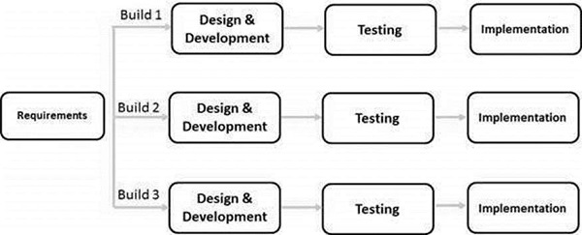

**Fig 3.1** Iterative Model Diagram

The phases in the Iterative design methodology are:

**Planning and Requirements:** The first phase is to go through an initial planning stage to map out the specification papers, determine software or hardware needs, and prepare for the cycle's subsequent stages.

**Analysis and Design:** Following the completion of the planning phase, an analysis is carried out to determine the suitable business logic, database models, and other elements that will be required at this point of the project. The design stage takes place here as well, and this is where any technical requirements that will be used to satisfy the demands of the analysis stage are established.

**Implementation:** Up until this stage, all planning, specification, and design documents have been coded and incorporated into the project's first iteration.

**Testing:** After this build iteration has been developed and implemented, the next step is to go through a set of tests to discover and locate any potential flaws or issues that have arisen.

**3.2.3 Data Dictionary**

A Data Dictionary is a collection of names, definitions, and attributes about data elements that are being used or captured in a database or an information system. It is used to catalog and communicate the structure and content of data and provides meaningful descriptions for individually named data objects. Below is the data dictionary for the sales order processing and invoice system. 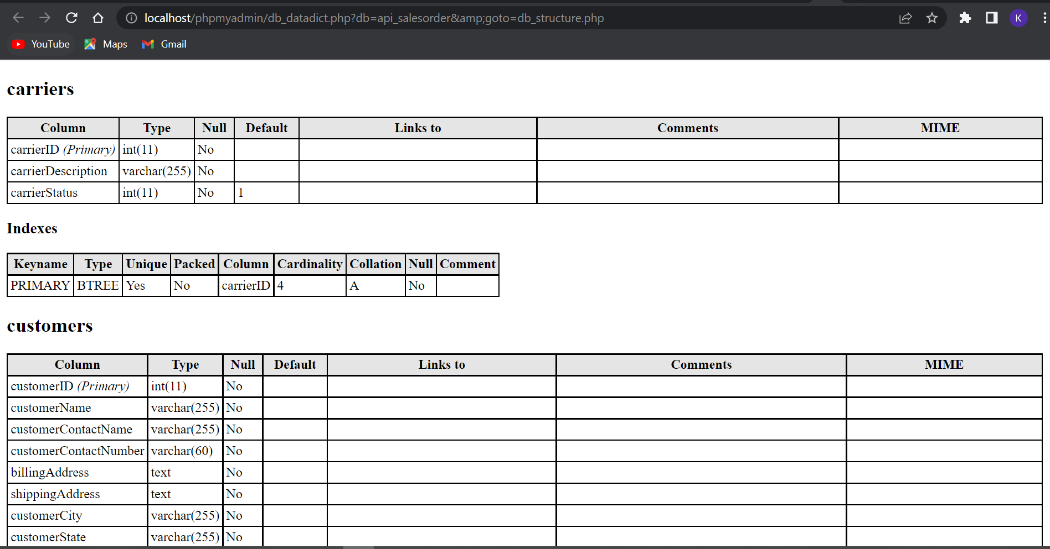

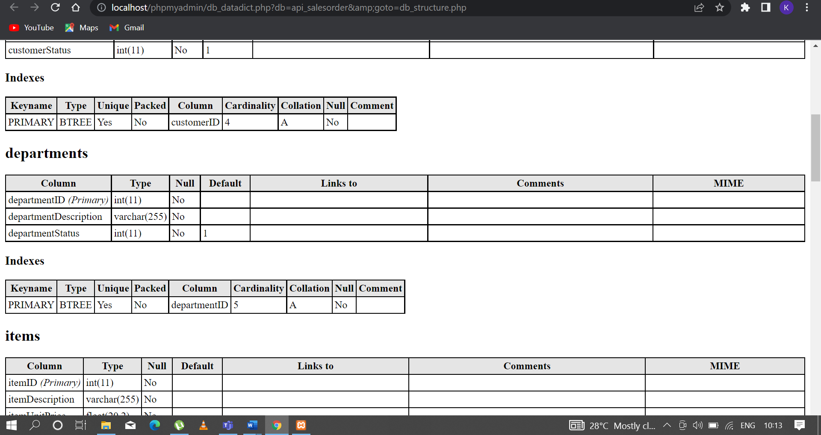

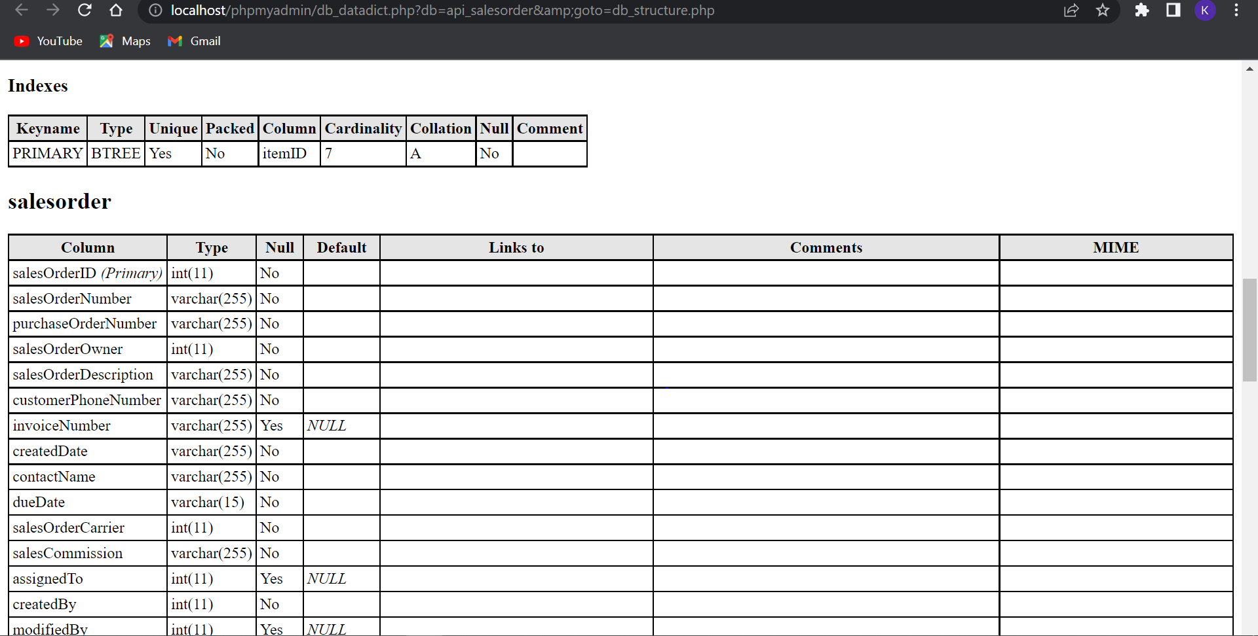

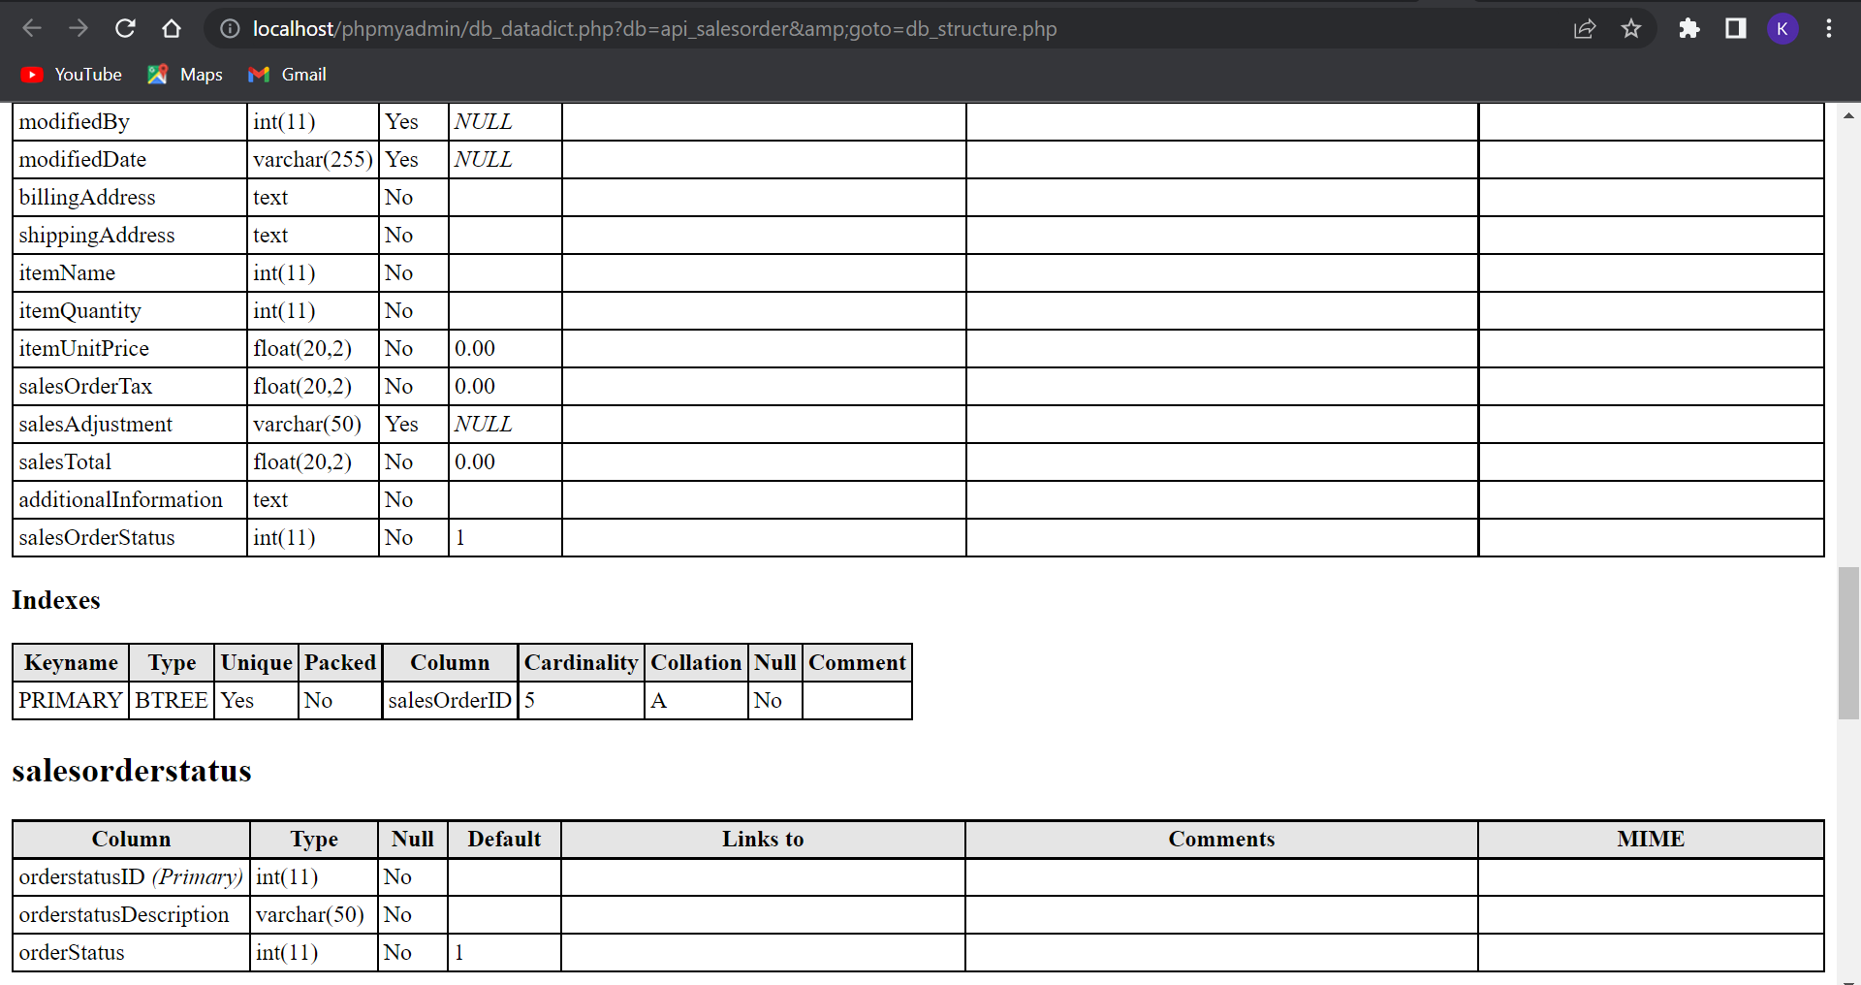

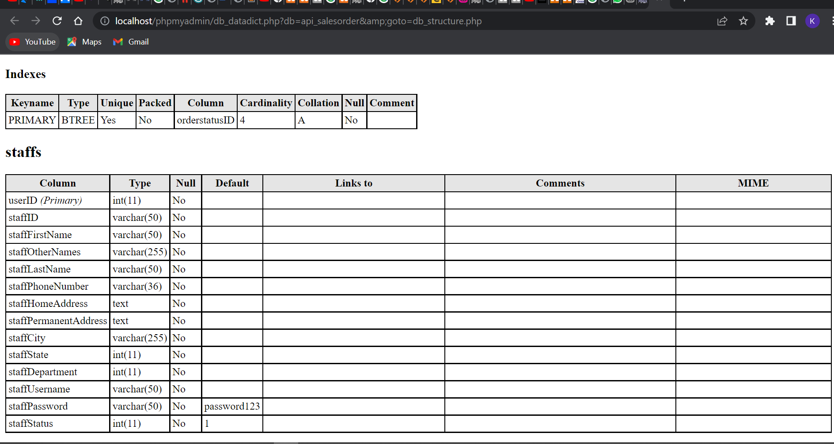

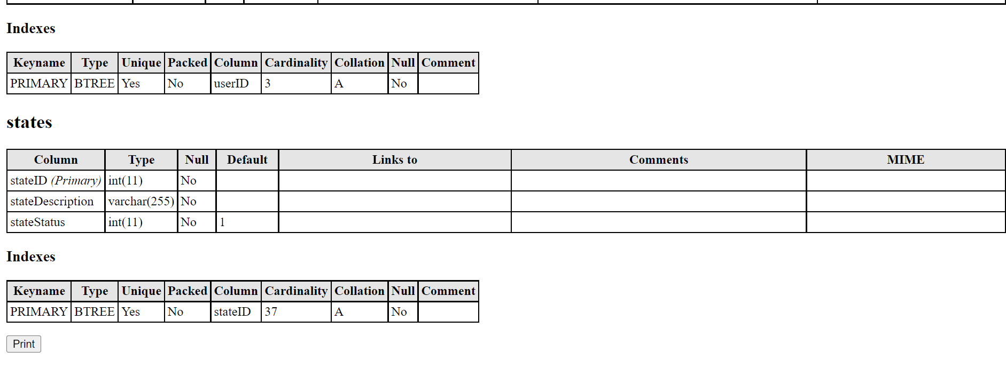

**3.2.4 Data Flow Diagram**

Once the data is gathered, next step is to transform into the required format to make it ready for the mining process, which is known as a pre-processing phase. It is a crucial step in data mining systems that aspire to transform the raw data into a proper format for resolving a particular problem. It has been observed that the finer the pre-processing task is done of the raw data, the more useful and suitable information is possible to discover. A schematic illustration of the proposed methodology is depicted in the figure below.

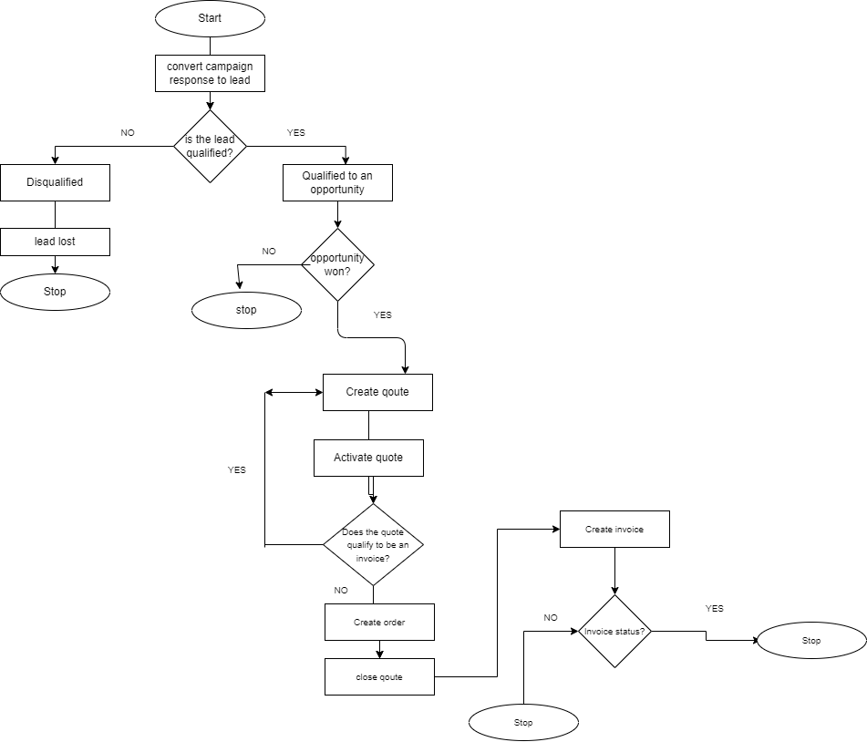**Figure 3.2** Showing Data flow diagram of the proposed system.

**3.2.5 Use Case Diagram**

The use case diagram in depicts the possible interaction between the user and the interface. They are actions to be taken by the actors (users and admin) for this use case model the actors users and admin are students and lecturers. The diagram below explains the action being carried out by the actors on the interface.

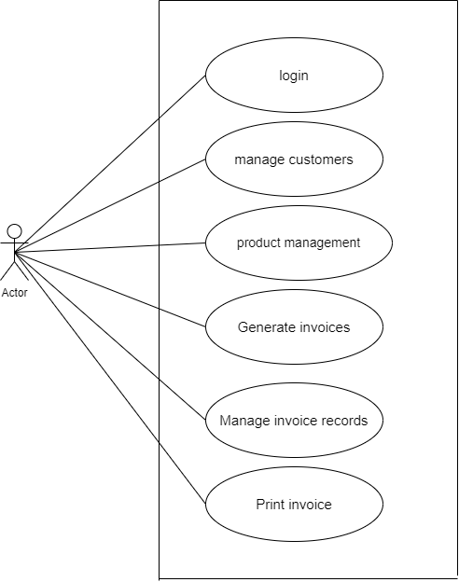

**Figure 3.3** Shows the use case diagram for the system.

**3.2.6 Enhanced Entity-Relationship Diagram (EERD)**

EER diagrams is a visual representation of data based on the EER model that is an extension of the original entity-relationship (ER) model.

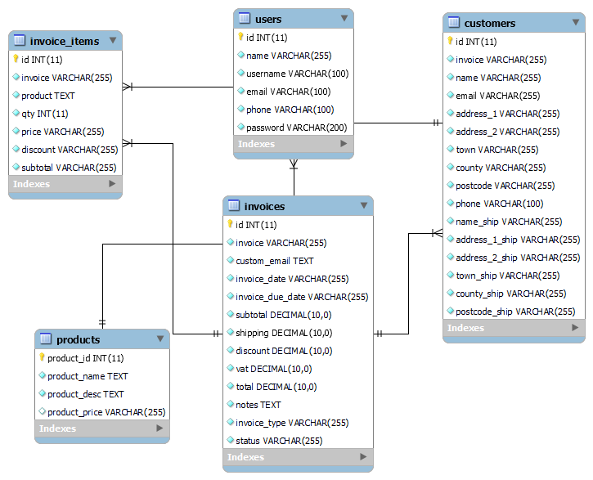

**Figure 3.4** showing the EER diagram of the system.

**3.3 REQUIREMENTS**

Requirements are statements that identify the capability, quality factor and functionality of a system which allows it to be useful and have quality to the user (Eze.M. 2021).

**3.3.1 System Requirements**

The following system requirements would be required for any device to run the system:

1. A minimum of windows 7 professional and above
2. JavaScript-enabled web browsers like Mozilla Firefox, Google Chrome, Internet explorer.
3. Internet connectivity or LAN card of speed 10mbps

**3.3.2 Functional Requirements**

The basic system behaviour is defined by functional requirements. They are essentially what the system does or does not do, and they may be viewed of as how the system responds to inputs. Calculations, data input, and business processes are frequently included in functional requirements. The functional requirements include:

1. The system shall allow for the registration and creation of customers.
2. The system shall allow users to edit customer details.
3. The system shall allow users add new products.
4. The system shall allow users to search for products.
5. The system shall generate a quote for purchase.
6. The system shall generate an invoice.

**3.3.3 Non-Functional Requirements**

A non-functional requirement is a specification that outlines the system's operation capabilities as well as the limitations that help it perform better. These can include things like speed, security, and dependability etc. The non-functional requirements of this system are as follows:

1. The system shall be available on all days of the week for twenty-four hours in a day.
2. The system shall have response time of no more than 1 seconds.
3. The system shall have a downtime of no more than one minute.
4. The system shall authenticate users by the use of email address and phone numbers.
5. The system shall generate an invoice after an order has placed done within 5 second

**CHAPTER 4**

**IMPLEMENTATION & TESTING**

**4.0 INTRODUCTION**

This section provides a description of how the implemented system meets the requirements specification. It includes an overview of some of main problems confronted, and the solutions adopted. It also keeps a chronologically journal of the coding and implementation, describing all of the obstacles faced.

**4.1 TECHNOLOGICAL ANALYSIS**

Technological analysis determines the type of technology available and technological consideration and constraints for delivery of the solution. In essence, a technology analysis helps yield information about the infrastructure capabilities of a company and the current technologies being used. Media analysis, an inherent part of technology analysis yields information on the most appropriate delivery systems for a particular application, given the state of infrastructure of the target organization.

#### **4.2 DEVELOPMENT PHASES**

Developing this application was quite the learning experience, as each phase came with its own unique challenge. The created web application is used to keep track of sales, customer, vendor data, accounts and generate an invoice for the customer.  This program manages the company's customers, clients, and sales prospects, as well as product purchase information, etc., until a product is purchased, and it handles every stage of the sales lifecycle. PHP, HTML, CSS, XAMP and the MYSQL database have all been used in the development.

### 4.3 IMPLEMENTATION

The webpages developed for the web application of this study provides the functionality for a sales order to be processed and an invoice generated. This section describes the web pages and functionalities as described:

1. **Login Page**

This page provides the administrator of this platform an interface to login to the main page for sales management. 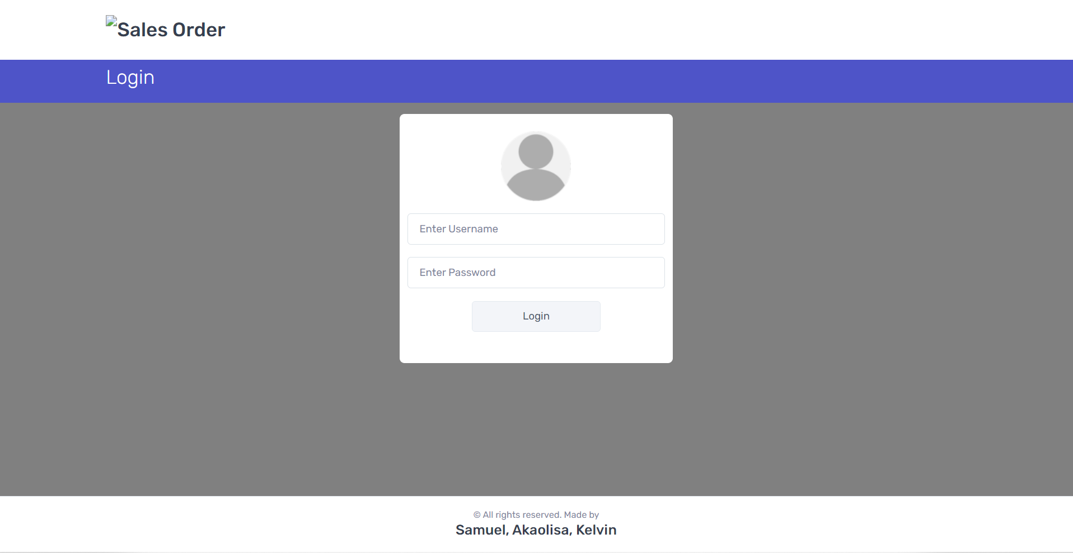

**Figure 4.1** Login Page

1. **Dashboard**

Figure 4.2 shows the Sales view of the system with different sub modules in sales such as new item, new item, new customer, new department, new staff etc. The web application contains customer’s account details such as their name, address, name of the organization they are associated to, contact details etc.

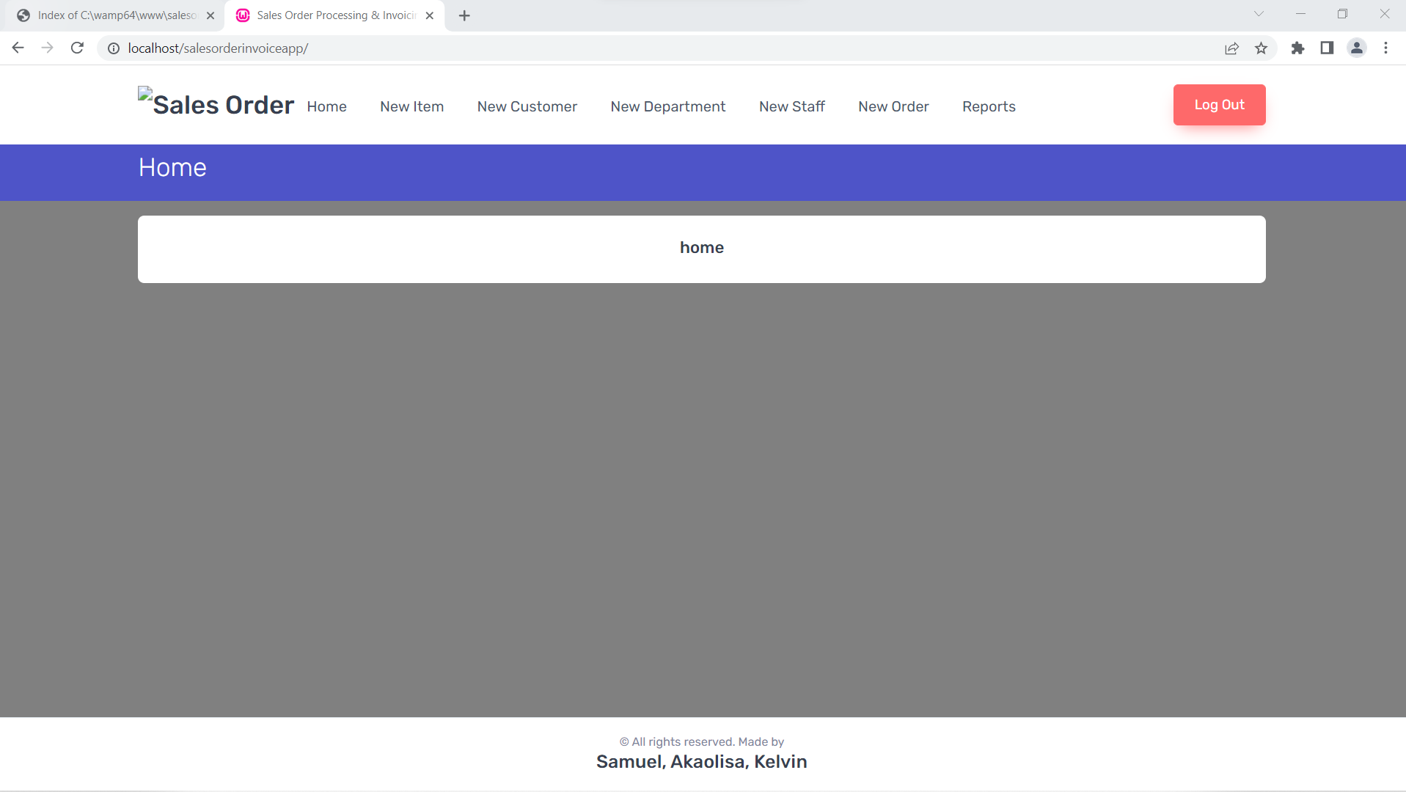

**Figure 4.2** Dashboard

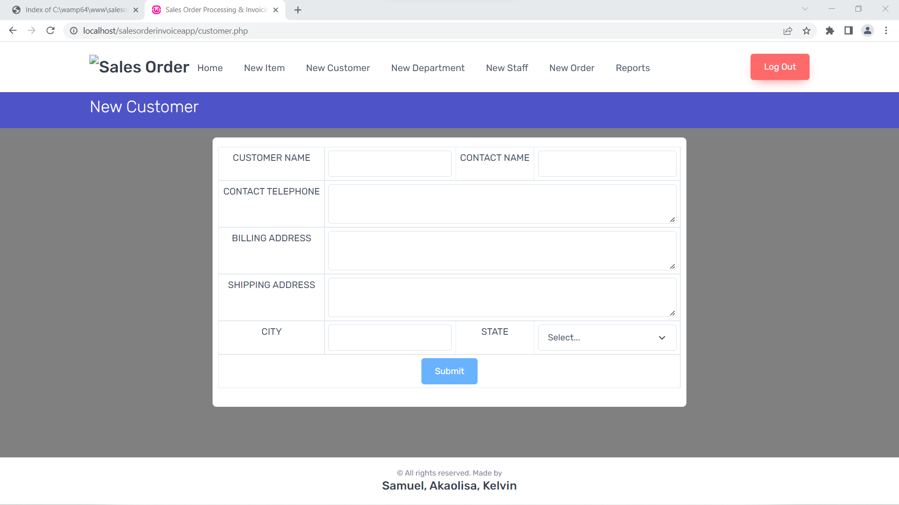

**Figure 4.3** Showing the addition of a new customer information and shipping information.

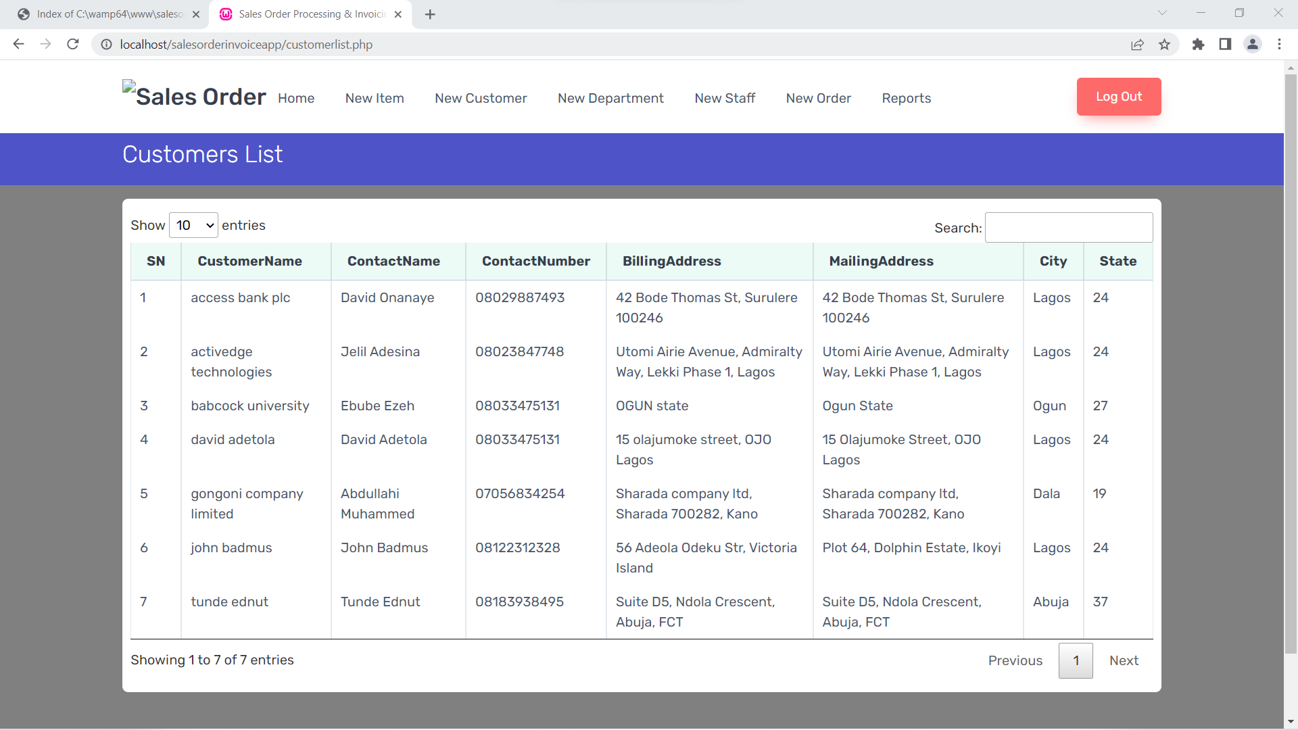**Figure 4.4** Showing the customer database.

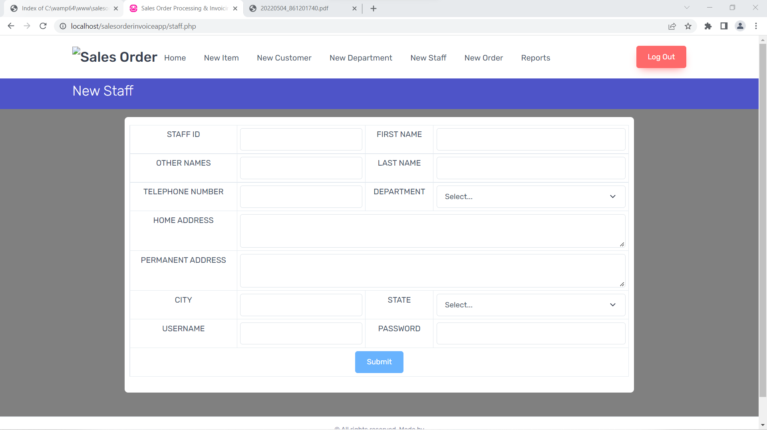

**Figure 4.5** Showing the addition of a new staff to the organization

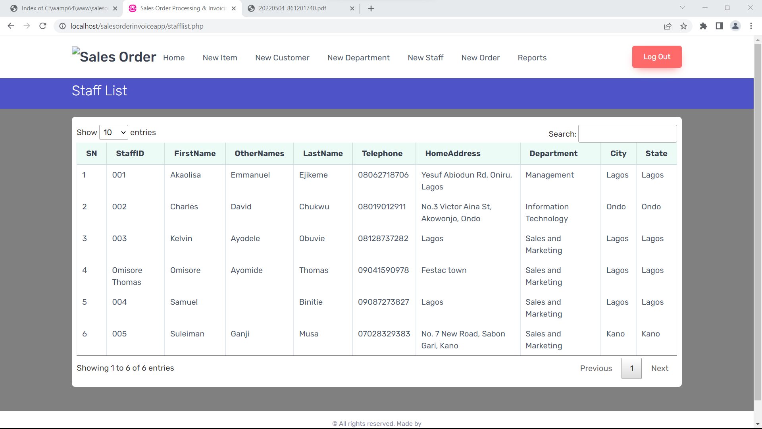

**Figure 4.6** Showing the list of staffs of the organization

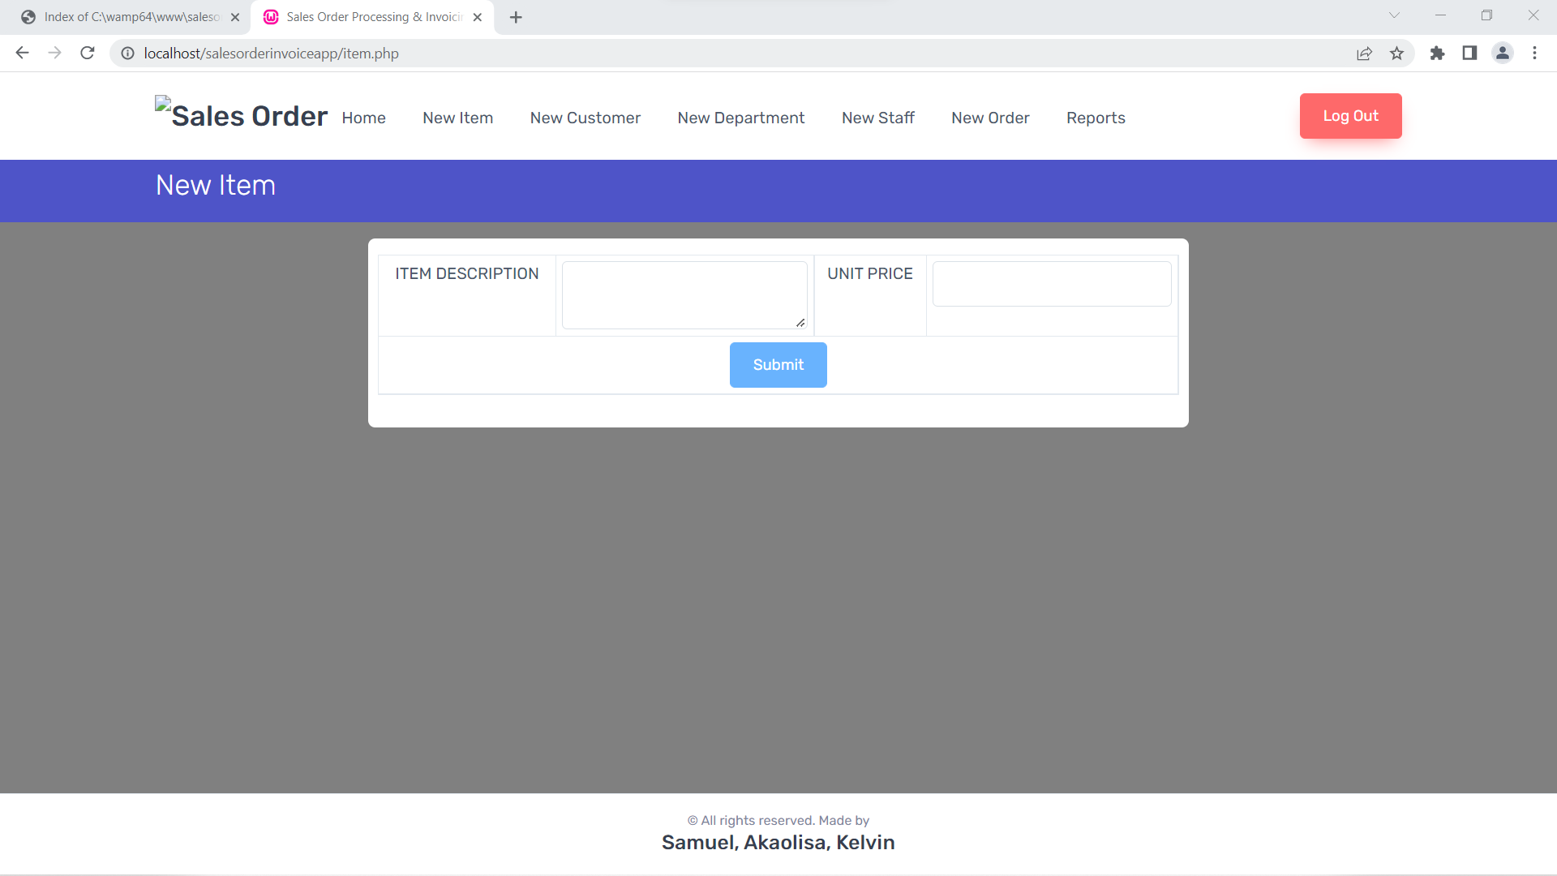

**Figure 4.7** Showing the addition of a new product into inventory.

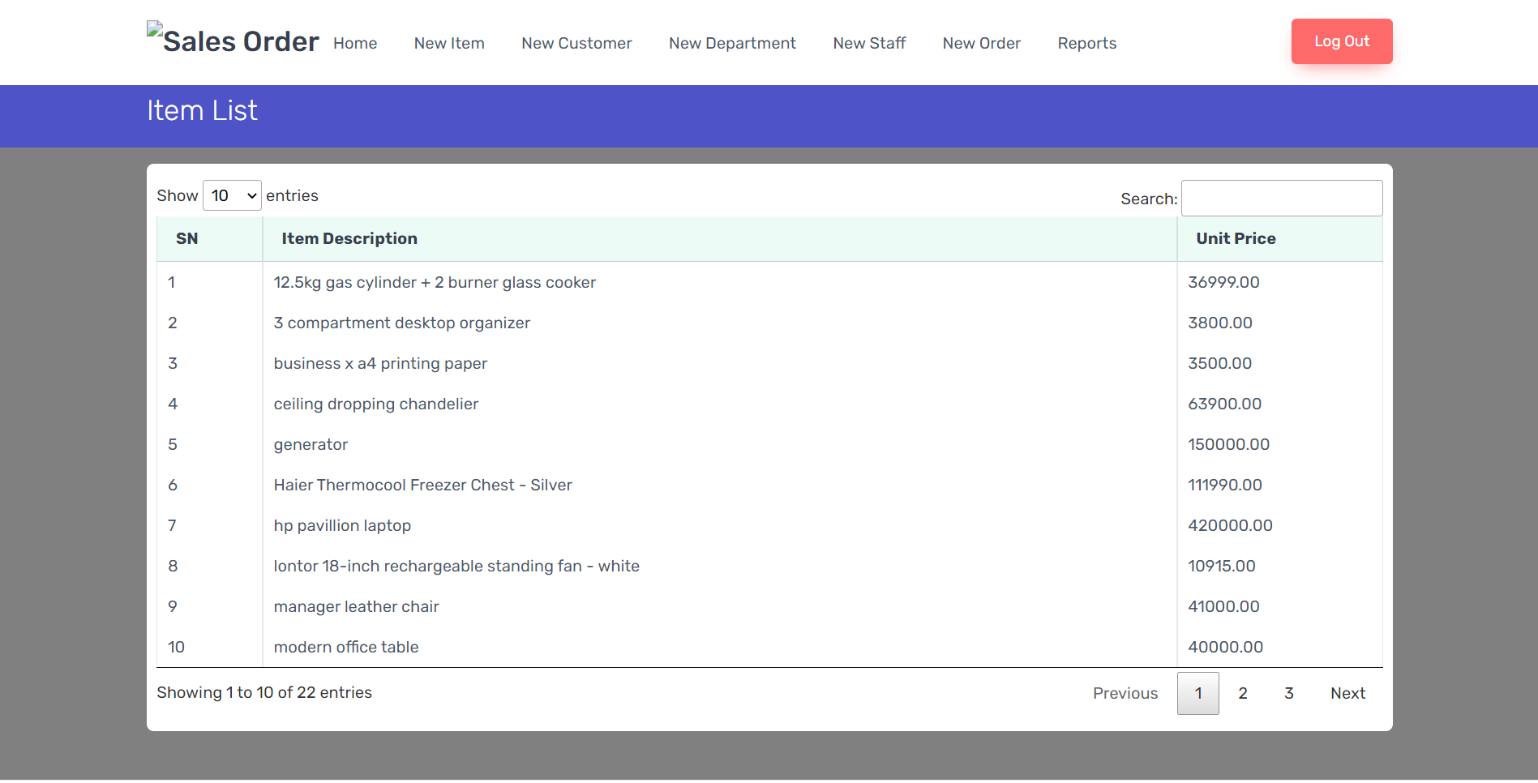

**Figure 4.8** Showing the products available in the inventory.

1. **Invoice**

A primary function of this system is to generate invoices based on sales. Nonetheless, for sales management, the admin can continue with the invoicing side of clients' orders. Here, an administrator must give due dates, client information, product item selection, and quantity. Additionally, the system allows for the addition of reduction amounts. Otherwise, the system will automatically add all extra sums, such as TAX and VAT, during the computation. The system initially shows each record as unpaid, and the user must edit records based on their bill status. In addition, the administrator has the option of include delivery costs. The system presents a clear invoice for each client as a result of this management. After that, the user may simply download the invoice file, which is in PDF format, to read it.

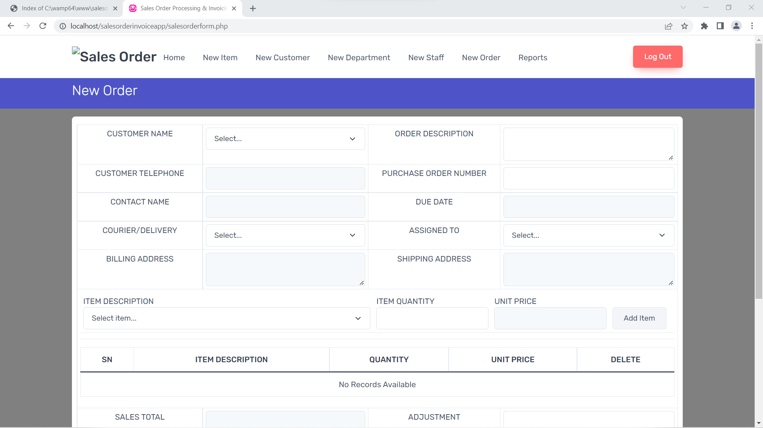

**Figure 4.9** Showing the generation of a new sales order for a customer.

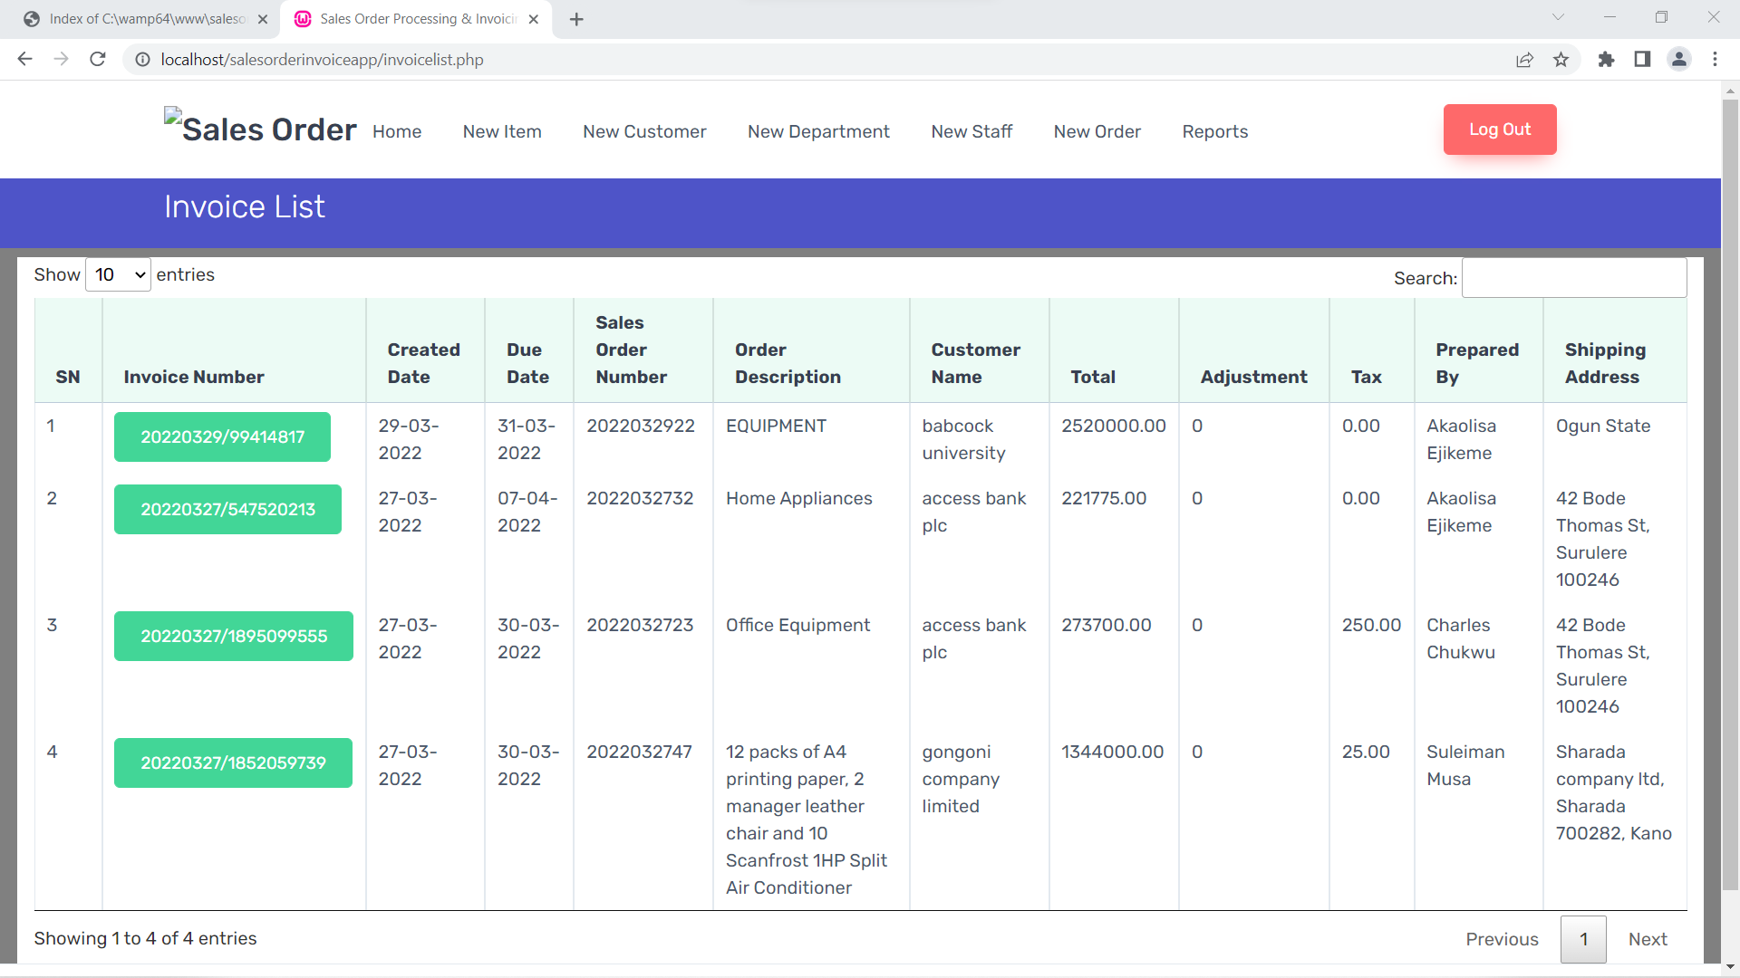

**Figure 5.0** Showing the database for invoices.

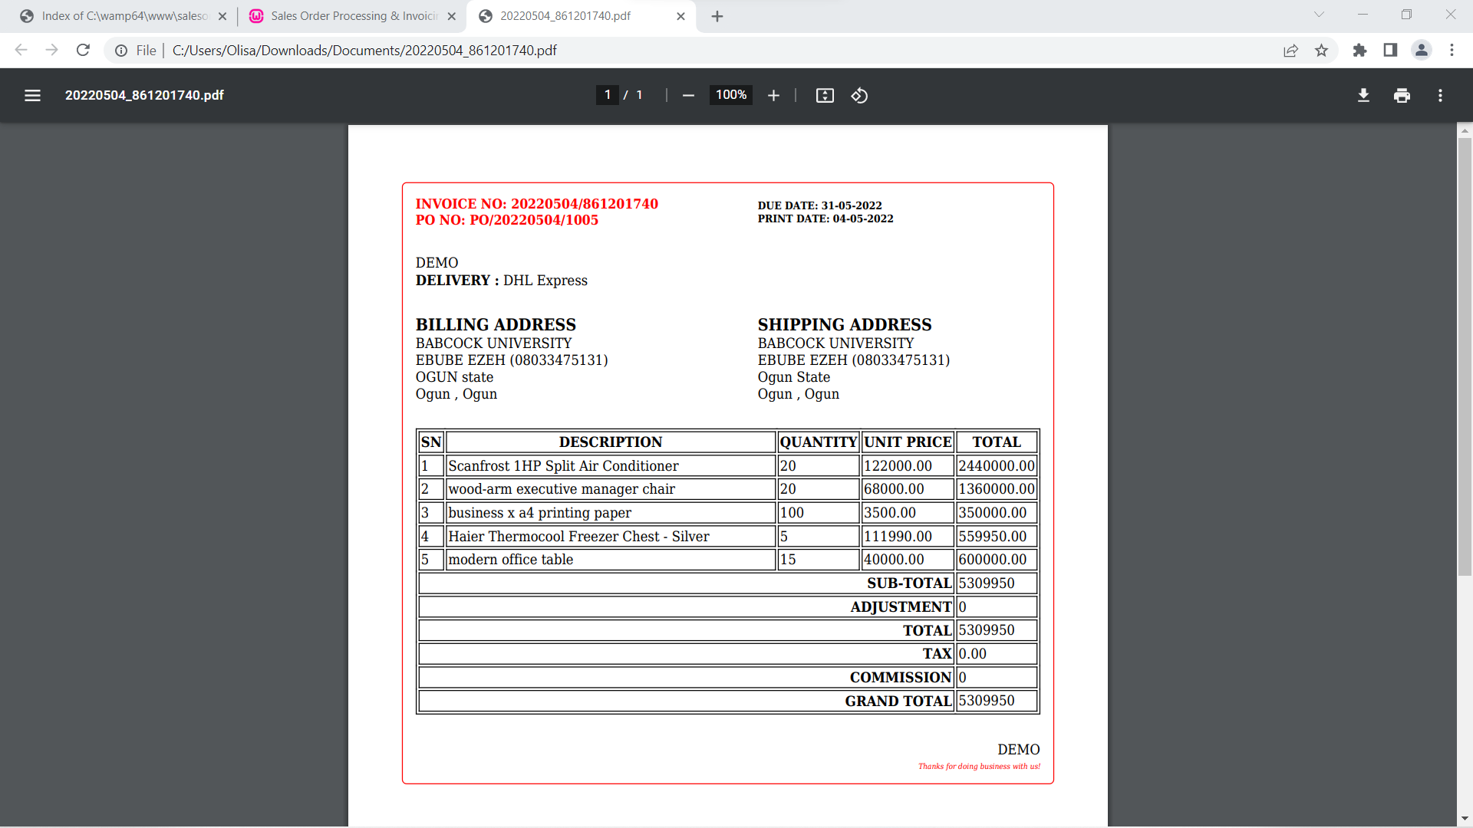

**Figure 5.1** Showing the pdf preview of an invoice for a customer

**4.4 TESTING**

Testing literally means subjecting a system to difficult challenges in order to verify its validity. From the above definition, testing involves two phases: verification and validation.

**4.4.1 Phases of Testing**

* Validation: Validation means to confirm or establish the truthfulness or soundness of a system. This phase of the testing process is done to ensure that indeed the system meets’ the users’ need. This phase gives answer to the question “did I build the right system?” Validation in software development is achieved by the use of prototypes. Prototypes were used to validate our online insurance company. A prototype is a scale-down replica or miniature representation of the real system. After a prototype is designed, the end users are allowed to test and criticize its functionalities. Any desired modification is then translated into the real system. After series of prototypes, a standard software is gotten as the end-product.
* Verification: Verification follows immediately after validation. Verification means that a system has been evidently proven to be true or correct. This phase answers the question “did I build the system right?” A right system is expected to verify users’ input such as login details before commencing processing, data entered into forms should be checked before entering into the database. Our specification and end-user requirements.

**4.4.2 Types of Testing**

* Component Testing

Component testing is the testing done on the constituent parts of the system. It is done to check each individual module before they are all combined into a whole. Component testing enables us to carefully study each module to ensure that they are functional. Component testing is very vital because the success or failure of a system depends wholly on the functionality of its constituents. Each module of the small insurance company application can run independently and was tested on its own. The system passes this test.

* System Testing

System testing involves integrating one or more components system functions or features and then testing this integrated system. The system is tested as a whole during system testing. It involves performing a progressive overall testing of the system’s objective to ensure that the system has met its objective and there are no defects before deployment is done.

* Database Testing

Database testing involves testing the database used for this application to ensure that it is successfully connected. The table (entities) of the database are also confirmed to have correct attributes (properties) and data types.

All the queries to the database (SELECT, INSERT, DELETE, UPDATE etc.) are also tested to be in their correct syntax. Referential integrity rules are also checked to ensure that the primary and foreign keys are properly used. The database is free of redundancy (unnecessary duplication of data) if referential integrity is used.

Database testing involves the tests to check the exact values which have been retrieved from the database by the web or desktop application. Data should be matched correctly as per the records are stored in the database. In testing the database, we ensured the database captures the specified fields according to their respective attribute. We also ensured that the storage and retrieval functions of the database functioned properly. We made sure that all the table carrying respective information are easily accessible by the user of the system.

* Performance Testing

Performance testing entails testing a system for its effectiveness in terms of reliability, speed, flexibility, scalability, resource usage etc. Performance tests have to be designed to ensure that the system can accept and process its intended load. Performance testing thrives to build systems that perform as optimally as possible.

Performance of this system was optimized with the use of functions for coding. With functions, there were lesser number of codes for the server to process; hence the speed increased. Resources like disk space and processor usage are conserved.

* Process Testing

Testing is the process of running a system with the intention of finding errors. Testing enhances the integrity of a system by detecting deviations in design and errors in the system. Testing aims at detecting error-prone areas. This helps in the prevention of errors in a system. Testing also adds value to the product by conforming to the user requirements. In testing the process, we started the system and we ensured that it is working perfectly. When s user logs into the system, s/he is directed to his/her dashboard, where there are links to other part of the application like profile, premiums, current policy, and he/she can see which premium is about to expire therefore making sure that the application queried the database and the appropriate data are inserted and returned.

* Interface Testing

Graphical user interface testing is the process of testing a products’ graphical user interface to ensure it meets its written specifications. This is normally done through the use of variety of test cases. In developing the interfaces of the system, we ensured that the prescribed format was used when requesting for the desired data from the database. This application helped in the input and output design. The interface was properly tested to ensure that it queries the database and the appropriate data are inserted and returned.

* Interconnection Testing

In the interconnection testing which is the testing between two or more systems the application was installed on a central server and client systems connected to the system on a wireless network and they were all able to access the application from the server and there was no problem in the queries from the database.

## **4.5 DISCUSSION OF RESULTS**

As shown in the above figures, the main advantage of implementing this system for an organization is that it solves the problems that exist in the sales management system with the implementation of an easy-to-use/friendly user interface and an automatically generated invoice.

**4.6 CHAPTER SUMMARY**

This chapter covers the implementation, presentation and operation of the sales order processing and invoice system and how to use the System. The chapter looked at how the technologies and the entire system work as a whole and how testing took place to ensure that they meet the user requirements. Users of this system have also been provided with a simple user guide. The guide the user with information on how to use the system effectively without any pr

**CHAPTER FIVE**

**SUMMARY, CONCLUSION AND RECOMMENDATION**

**5.1 SUMMARY**

This section examines the project as a whole and explains how the resulting system met the project’s initial goals. It also gives a summary of the project’s lesson learned and accomplishments. This project's goal was to create a sales order processing and invoice system for an organisation. A manual system research was conducted by monitoring the manual system in order to accomplish this.

**5.2 RECOMMENDATION**

In light of future trends of increased rivalry in the office automation industry, the following are some recommendations for the firm to make in order to change the Sales Management System to suit future demands:

To keep up with the strong competitiveness, a real-time information system should be designed to fulfil future demand as business grows.

Another future trend to create is an on-line interactive procedure for sales management information systems, which may assist customers and employees get information with the least amount of waiting time, resulting in improved customer and employee satisfaction.

One technique for generating real-time information for customers in order to extend the market countrywide or deal with a crisis is to use an Internet-based information system

**5.3 CONCLUSION**

The sales order processing and invoice system project has been validated and verified. It meets up to the goals that were initially set at the onset of the project. The objectives of this study as initially stated in the previous chapters have been met. Sales order and invoice Management is a critical component of every business that must be handled with care. The deployment of these system has increased productivity, kept staff informed, and provided administrators with the information they need to make key choices.

**REFERENCE**

Adminastro. (2021, November 15). Invoice Management System in PHP with Source Code.

https://codeastro.com/invoice-management-system-in-php-with-source-code/

Edwards, J. (2022, March 22). *JD Edwards World Sales Order Management Guide.* Retrieved from oracle.com: <https://docs.oracle.com/cd/E26228_01/doc.93/e21562/ovrvw_sls_ordr_mgmt.htm#WEASO108>

gocardless. (2003, july). *gocardless invoicing.* Retrieved from gocardless invoicing: <https://gocardless.com/guides/inviocing/paper-vs--paperless-invoicing/.8>

Katesuda Suvannoy , K. (1998, April). *Sales Order Processing System Of Mitsiam Plastics Co.,LTD. .* AU-IR Home. <https://repository.au.edu>.

Khwanfa Muangsiri , K. (1998, November). *Sales Management Sytem.* Google scholar. <https://scholar.google.com/scholar?start=10&q=sales+order+processing+and+invoice+system&hl=en&as_sdt=0,5>.

Kitsanarangsan, C. (2002, September). *EXPORT ORDER PROCESSING SYSTEM.* Google Scholar. <https://scholar.google.com/schhp?hl=en&as_sdt=0,5>.

Klungsupavipat , . (2004, March). *Order Processing System for Domestic And International Business .* AU-IR Home. <https://repository.au.edu>.

Lele Liu Et a (2004). Establishing an Electronic Invoice Management Platform Based On Information System*. Journal Of Physics: Conference Series*.

Mensah, A. (2003, june). *scribd.com.* Retrieved from scribd.com: <https://www.scribd.com/doc/199450108/Sales-Order-Processing-Project-Documentation>

Muzorewa, S., & Rao,, . (2012). SALES ORDER PROCESSING AND INTERNAL CONTROLS *. Journal Of the International Academy for Case Studies, Volume 18, Number 2,*.

Parichat , P. (2003, July 1). *Order Processing System for Thai Plastic Supply Co., Ltd. .* AU-IR Home. <https://repository.au.edu>.

Puvanasvaran, Kerk, R., & Ismai. (2010). A CASE STUDY OF KAIZEN IMPLEMENTATION IN SM*. National Conference In Mechanical Engineering Research And Postgraduate Studies (2 Nd NCMER 2010) 3-4 December 2010, Faculty Of Mechanical Engineering, UMP Pekan, Kuantan, Pahang, Malaysia; Pp. 374-392 ISBN: 978-967-0120-04-1; Editors: M.M. Rahman, M.Y. Taib, A.R. Ismail, A.R. Yusoff, And M.A.M. Romlay ©Universiti Malaysia Pahang*.

Rochanasmith , J. (2003, November). *Order Processing System For ALT Agrochemical Co., Ltd. .* AU-IR Home. <https://repository.au.edu>.

Routh, a. (2017, june). *ieeexplorer.ieee.org.* Retrieved from ieeexplorer.ieee.org: <https://ieeexplore.ieee.org/abstract/document/8029235/authors#authors>

Sanam Kadge, Uzair Khan Student B.E, Arsalan Thange, Shamail Mulla, & Harshika Gupta. (2012). International Journal Of Computer Applications (0975 – 8887) Volume 136 – No.10*. Sales And Invoice Management System With Analysis Of Customer Behaviour*.

Tatiyajaruwong , V. (2001, November). *Order Processing System for Akekarat Co., Ltd..* <https://repository.au.edu/>.

T. D. (2022, February 25). 10 Best Project Management Software With Invoicing. *The Digital Project Manager*. thedigitalprojectmanager.com. Retrieved March 22, 2022, from <https://thedigitalprojectmanager.com/tools/best-project-management-software-invoicing/>

T.Papaioa, & J.Edwar. (1998). Mobile Agent Technology In Support Of Sales Order Processing In the Virtual Enterprise*. Mobile Agent Technology In Support Of Sales Order Processing In the Virtual Enterprise*. 10.1007/978-0-387-35390-6.